ENJOY YOUR GAMING TO THE FULLest
Sennheiser introduces its new 7.1 surround sound gaming headset GSP 550

Ballerup, August 30, 2018 – Your gaming world just got bigger: With its thrillingly expansive surround sound, Sennheiser’s new GSP 550 headset lets you experience your games as never before. The audio specialist’s new high-end open acoustic headset for PC gaming features a truly enveloping 7.1 Dolby Surround Sound, with incredibly natural and high-fidelity audio, improved microphone performance, and increased comfort and durability.

The GSP 550 delivers a remarkable gaming experience: with a perfect combination of Sennheiser´s unmatched high-fidelity audio and 7.1 Dolby surround sound. Featuring a proprietary open speaker system from audio specialist Sennheiser it delivers a natural sound performance that balances excellent clarity with enhanced low frequency response that adds excitement to your gaming experience while Dolby 7.1 surround sound creates an expanded soundstage. The open acoustic design features specially positioned speakers within the ear cups that channel the sound directly into the ears.

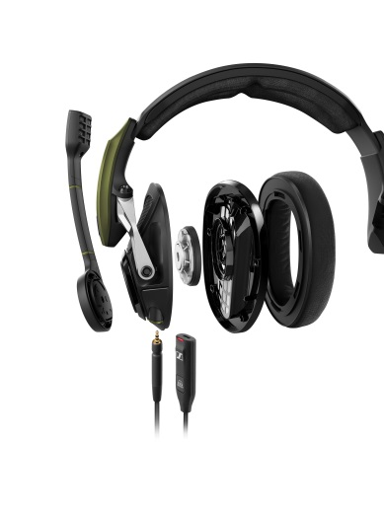 | The GSP 550 delivers a remarkable gaming experience: with a perfect combination of Sennheiser´s unmatched high-fidelity audio and 7.1 Dolby surround sound.
The GSP 550 gaming headset is paired with a sleek and intuitive Surround Dongle, designed to optimize the sound experience at a single click of its Dolby button. The intuitive PC software also lets you shape and customize your sound experience, with different surround sound modes and four equalizer settings for gaming, esport, music and an off setting which gives a neutral sound performance.

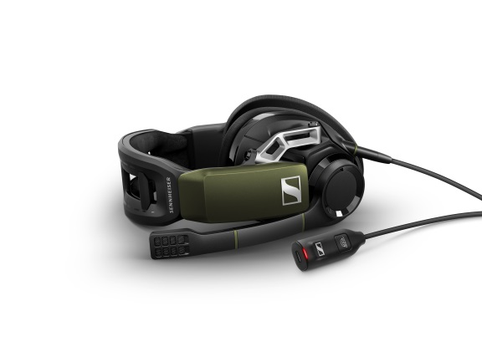 | The GSP 550 gaming headset is paired with a sleek and intuitive Surround Dongle, designed to optimize the sound experience at a single click of its Dolby button.
"Thanks to its Surround Dongle, the GSP 550 makes it effortless for gamers to tailor their sound experience via Sennheiser’s intuitive software to be exactly the way they want,” explained Andreas Jessen, Head of Product Management Gaming, Sennheiser Communications A/S. “We know that for dedicated gamers, lightning fast, intuitive controls are vital. This is why we created a streamlined user interface that, for example, lets you rapidly switch between stereo and surround sound at a touch.”

Superb comfort, tailored to you
No matter how long the gaming session, the GSP 550 keeps you cool and comfortable thanks to its ergonomic design and customized fit. It features an advanced, solid metal hinge with a
2-axis mechanism that gives the earcups greater freedom of movement. This durable system pivots smoothly to conform just as well to both narrow and broad jawlines for an improved fit. To better adapt to different head sizes, Sennheiser has integrated an innovative adjustable contact pressure mechanism into the headband that can be adjusted according to each user’s preference to ensure the headset feels perfectly snug and secure without ever feeling too tight. Ventilated ear cups are fitted with ergonomically designed ear pads covered with a soft and highly-breathable fabric.

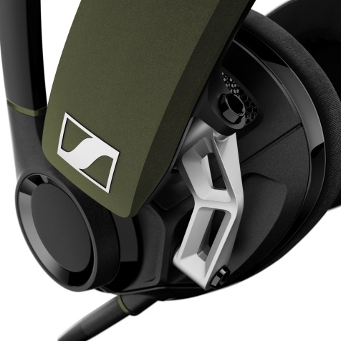 | The GSP 550 features an advanced, solid metal hinge with a  2-axis mechanism that gives the earcups greater freedom of movement.

Command the action with crystal clear communications
The GSP 550 has an advanced broadcast quality microphone with high-quality noise cancellation that guarantees crystal-clear communication. Three side tone settings, which can be selected via the software interface, allow gamers to choose exactly how much they hear their own voice. The mic can be quickly muted during gameplay by lifting the flexible boom arm and similarly, a volume control on the ear cup offers convenient on-the-fly adjustment.

Tough enough to take on any challenges
As a Sennheiser gaming headset, the GSP 550 has been build to exacting standards and with the durability that every gamer needs. The solid metal hinge and high-quality materials ensure outstanding lasting toughness, while exchangeable ear pads, cables, and cover plates and a two-year international warranty provide an added level of assurance.

The GSP 550 is available from end of October 2018 at the recommended retail price of 249.00€ or 249.95$. Bring more excitement and realism to your gaming experience with the Sennheiser GSP 550.

about Sennheiser
Shaping the future of audio and creating unique sound experiences for customers – this aim unites Sennheiser employees and partners worldwide. Founded in 1945, Sennheiser is one of the world’s leading manufacturers of headphones, microphones and wireless transmission systems. With 21 sales subsidiaries and long-established trading partners, the company is active in more than 50 countries and operates its own production facilities in Germany, Ireland, Romania and the USA. Since 2013, Sennheiser has been managed by Daniel Sennheiser and Dr. Andreas Sennheiser, the third generation of the family to run the company. As part of the Sennheiser Group, Sennheiser Communications A/S is a joint venture specialized in wireless and wired headsets and speakerphones for contact centers, offices and Unified Communications environments as well as headsets for gaming and mobile devices. In 2017, the Sennheiser Group generated turnover totaling €667.7 million. www.sennheiser.com
Global Press Contact

Anna Bornemann
Sennheiser Communication A/S
Head of Marketing, Gaming
T: +45 5618 0323
abor@senncom.com

